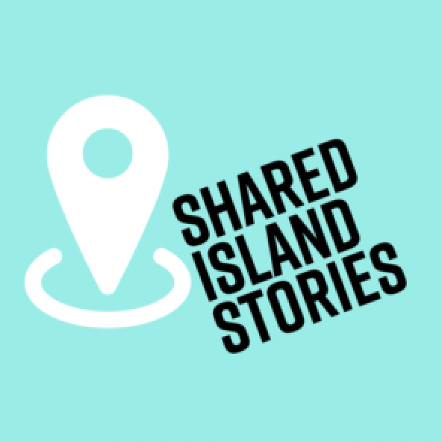

Transnational
youth exchange
Barbados-scotland

application form and information pack

contents

What is the ‘Shared Island Stories’ project? 1
TRANSNATIONAL YOUTH EXCHANGE INFORMATION 3
WHO WILL WORK WITH THE YOUNG PEOPLE? 5
TRANSNATIONAL YOUTH EXCHANGE TIMELINE 6
KEYPOINTS 6
TRANSNATIONAL YOUTH EXCHANGE CRITERIA 7
APPLICATION PROCESS AND HOW TO APPLY 8
Application Form: Personal & Additional Information 9
Application Form: TELL US ABOUT YOURSELF 10
Application Form: Code of Conduct 12
Application Form: EQUAL OPPORTUNITIES 13
Application Form: Medical, Dietary & Insurance Information 14
Application Form: CRITERIA QUESTIONS 15
What kit would I need to bring with me to SCOTLAND? 16
Photography and Video Consent Form 17
Parent/Carer(s) Consent Form (if under 18 years old) 18

What is the ‘Shared Island Stories’ project?

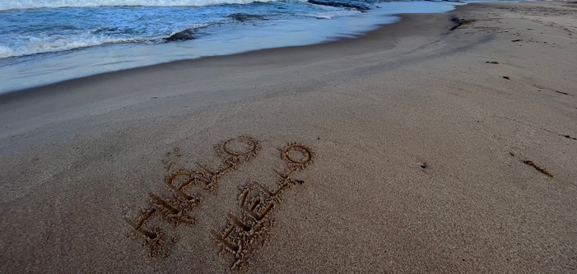
1 Cattlewash Beach with ‘Hello’ and ‘Halò’ – Halò is Scottish Gaelic for Hello

Islands are conventionally associated with romantic ideas of local distinctiveness and isolation, and yet those situated off the west coast of Scotland and the Caribbean share the growing problem of coastal erosion through rising sea levels and storm intensification, as well as economic recession, depopulation and inappropriate tourism development. Shared Island Stories Between Scotland and the Caribbean: Past, Present, Future is a 5-year research project coordinated by the School of Art History at the University of St Andrews in Scotland that aims to investigate relationships between the archipelagos.

Drawing on history, heritage studies, sustainable development, art history and memory studies, the project asks: Which collections from the islands tell unfinished stories of Empire? What is the role of heritage communities for sustainable development? How can island community museums partner with NGOs, policy and local organisations and businesses for climate action? How can health and well-being be understood in relation to community heritage, traditional ecological knowledge and island life? What does this new knowledge bring to debates on climate justice, especially as they relate to the role of youth?

The project is funded by the UK Research and Innovation Agency.

TRANSNATIONAL YOUTH EXCHANGE INFORMATION

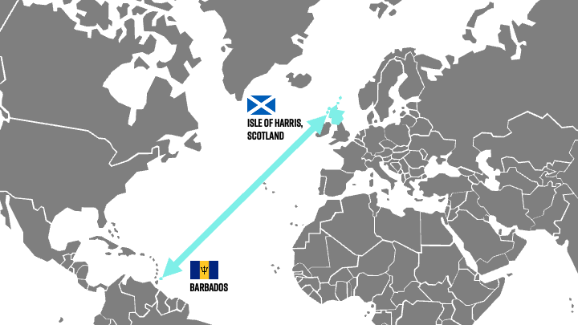
2 Transatlantic Map for Context

‘Shared Island Stories Between Scotland and the Caribbean: Past, Present, Future’ is a 5-year research project coordinated by the School of Art History at the University of St Andrews in Scotland that aims to investigate the relationships between the archipelagos. The project is funded by the UK Research and Innovation Agency.

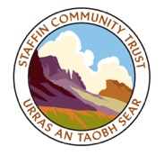
Shared Island Stories considers the ‘future’ primarily through a transformative transnational youth exchange between the island communities of the Isle of Harris in Scotland and the Caribbean Island nation of Barbados. The overall project is managed by the University of St Andrews. The transnational youth exchange is facilitated by the University’s School of Art History in collaboration with the West Harris Trust, the Barbados Museum & Historical Society and Barbados Community College.

Starting in January 2023 till late Summer 2024, a group of 6 young people from Barbados will participate in monthly workshops (dates to be confirmed) themed around the United Nation’s Sustainable Development Goals (SDGs). Each workshop will focus on community heritage and the effects of climate change on island communities, as well as considering the similarities and differences in the landscape, food and other cultural influences between Scotland and the Caribbean. Workshops will seek to empower the young people involved to build self-confidence, social capacities, climate awareness and oral-history skills via using audio, video and drone technology.
The young people involved will become “Youth Ambassadors” for heritage and climate change in their respective schools, community groups, countries and internationally through our conference.

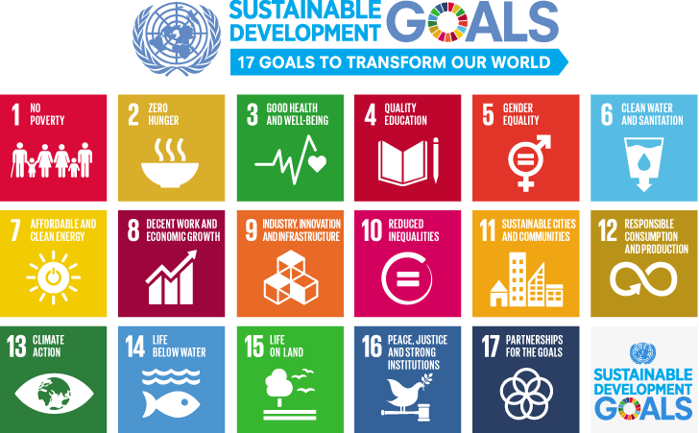
3 Sustainable Development Goals (SDGs)

In between workshops, young people will be encouraged to explore the landscape together with documenting their personal thoughts and overall reflections through an online journal. The workshops will be held both in-person and virtually, with invited University, community, and youth speakers. At the same time, the University of St Andrews and West Harris Trust will lead workshops with young people in Scotland based at their community centre.

During late summer 2023, the Scottish young people from the Isle of Harris will travel to Barbados to take part in a transnational exchange visit. Offering an opportunity to compare their own community, identity, heritage, and culture with the island nation of Barbados. They will be encouraged to share their workshop experiences to find collective solutions to the challenges of climate change and daily life. In late summer 2024, the Scottish young people will welcome the Barbadian young people to the Isle of Harris and the Outer Hebrides for their transnational exchange visit.

The transnational youth exchange will be accredited through the Scottish Government’s Saltire Award volunteering certification and Archaeology Scotland’s Heritage Heros programme. During Summer 2024, the young people will be awarded their certificates at the Shared Island Stories project conference at the University of St Andrews. The certificates can be used towards university, college, apprenticeship and employment applications. All young people will be able to utilise the project as a future reference for such applications.

WHO WILL WORK WITH THE YOUNG PEOPLE?

The primary contact for the transnational youth exchange in Barbados will be Kaye Hall, who has been appointed by the Barbados Museum & Historical Society as the Education and Community Outreach Officer who will lead the programme in Barbados. Kaye fosters partnerships with regional education bodies to ensure the propagation and revitalisation of heritage education, as well as with schools, colleges, communities and individual students to ensure that the inculcation of heritage is a rewarding lifelong learning experience. Kaye will be working in collaboration with Michelle Cox, who is the Theatre Arts Coordinator at the Barbados Community College. Michelle is a Theatre Practitioner and Educator. Her primary interest is the safeguarding of Caribbean Intangible Cultural Heritage through the development of a dynamic teaching environment and interactive theatrical presentations.

The primary contact for the transnational youth exchange in Scotland will be Jamie Allan Brown, who has been appointed by the University of St Andrews as the Research Fellow who will lead the ‘future’ element of the project. Jamie has previously coordinated several international community and youth programmes, including a bi-regional youth exchange between the Isle of Skye, Costa Rica and Portugal. The overall project is coordinated by Professor Karen Brown from the University of St Andrews. Karen is an expert in Museums and Heritage Studies relating to community, sustainability, cultural memory and specialises in community-based museums in Europe, Latin America and the Caribbean region.

All University of St Andrews staff and students involved are members of Disclosure Scotland’s Protection of Vulnerable Groups Scheme (PVG Scheme) in accordance with Scottish Government legislation and the University of St Andrew’s protection of vulnerable groups and criminal records check policy. In Barbados, the Barbados Museum & Historical Society follow local legislation and guidance.

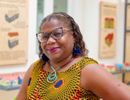  Kaye Hall  Education and Community Outreach Officer Barbados Museum & Historical Society, Barbados | Michelle Cox  Theatre Arts Coordinator  Barbados Community College, Barbados
Professor Karen Brown  Project Lead & Principal Investigator  University of St Andrews, Scotland | Jamie Allan Brown  Research Fellow  University of St Andrews, Scotland

TRANSNATIONAL YOUTH EXCHANGE TIMELINE

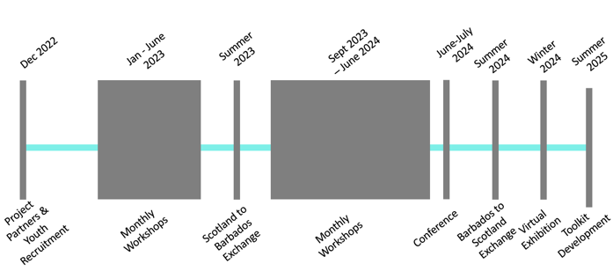
4 Timeline

KEYPOINTS

The main language of communication will be English, however, the Scottish young people will be expected to share Gaelic language and culture from the Isle of Harris, similarly, the Barbadian young people will share Bajan dialects of the English language and both national and regional Caribbean culture.

The project is funded by the UK Research and Innovation Agency which covers the cost of each young person travelling. The funding also covers basic subsistence (meals and drinks) and accommodation during this transnational youth exchange.
Young people will be expected to access an internet connection for attending virtual workshops and completing online reflective journals from January 2023 to late-summer 2024.

The young people will be asked to complete a comprehensive medical form and seek advice from their doctor regarding vaccinations and general health. We will require a GP stamped medical form confirming the young person is in good health and received the recommended vaccinations to take part.

TRANSNATIONAL YOUTH EXCHANGE CRITERIA

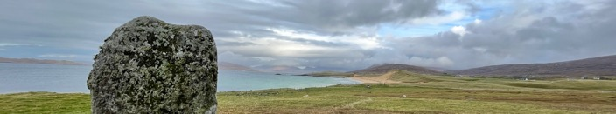
5 Clach Steineagaidh Standing Stone, Isle of Harris, Scotland

The project is looking for 6 fully committed young people (aged 16-25yrs) to take part who meet the following criteria;

- You must be 16 years old by the time of travel to Scotland (unfortunately there are no exceptions due to legal insurance requirements);

- You must have an interest in local heritage, climate change and the issues facing island communities;

- You must have a demonstrated interest in cultural heritage and hold Barbados citizenship;

- You must be respectful and open to different cultures and experiences;

- You must have a valid Passport for travel by summer 2024;

- You must follow your doctor’s medical advice for vaccinations and health guidance;

- If you are under 18 years old, you must have your parent/carer(s) full permission and consent to take part;

- Most importantly, you must be committed to attending all monthly workshops held either in-person or virtually, attend the in-person transnational youth exchange visit to Scotland (summer 2024) and welcome the Scottish young people to Barbados for their in-person transnational youth exchange visit (summer 2023).

Remember to check the latest Government advice for travelling to Scotland and the UK.

APPLICATION PROCESS AND HOW TO APPLY

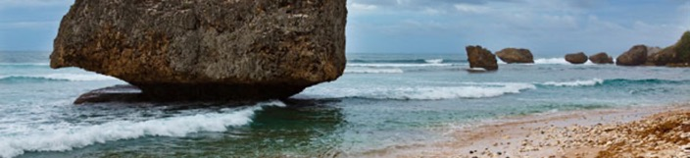
6 Bathsheba Rocks, Saint Joseph Parish, Barbados
The project requires applicants to follow the process below;

- Attend an information session at Barbados Museum & Historical Society – Kaye Hall will confirm the details of this event.

- Record a short 5-minute video telling us about you, your community, your concerns about climate change in Barbados and why you would like to take part. – Kaye Hall will confirm the details of this deadline.

- Complete and submit this application form. – Kaye Hall will confirm the details of this deadline.

- If you meet all the eligibility criteria, Kaye Hall may invite you to a 10-minute informal virtual interview via Microsoft Teams or Zoom. – Kaye Hall will confirm the details of this deadline.

- You will be contacted via email or telephone to advise of the outcome of your application.

If you have any questions or queries, please contact Education and Community Outreach Officer, Kaye Hall via educate@barbmuse.org.bb

Application Form: Personal & Additional Information

Full Name:
Gender: |  | Preferred Pronouns:
Date of Birth:
Home Address

Landline Telephone: |  | Mobile Telephone:
Email:

Would this be your first international exchange?

Do you have any particular dietary requirements?
Do you have any medical conditions you wish to make us aware off? (Further medical questions on Page 10)
Can you swim?

T-Shirt Size
(For ordering T-Shirts, if successful)

Application Form: TELL US ABOUT YOURSELF

These questions are an opportunity for us to get to know a bit about you and why you want to take part in the transnational youth exchange. We advise that you write using your own words.

If you need more space, please write on a separate sheet or document, and attach it together. Don’t worry if the document moves about.

Remember, you don't need specific skills or experience– but we are looking for young people who are fully committed to the project and championing solutions to the challenges facing island communities such as climate change. We are also looking for young people who want to share the heritage of Barbados and Scotland across the world.

Please state why you would like to be involved in ‘Shared Island Stories’ and why it is important to you to champion local heritage and climate change.

What strengths can you bring to this transnational youth exchange? Please give an example of being committed to a previous project you were involved in.

What will you find challenging in the workshops and planned in-person transnational visits?

What climate change-related issues are facing your community in Barbados?

Do you study, have previously studied or have an interest in cultural heritage? If so, how would you share cultural heritage with other young people?

Application Form: Code of Conduct

Parent/Carer(s)  Signature: |  | Date:
Young Person’s  Signature: |  | Date:

TO BE READ BY THE YOUNG PERSON (AND THEIR PARENT/CARER(S) IF UNDER 18 YEARS OLD) - By completing this application form you are accepting our code of conduct and agreeing to abide by the following rules during this transnational youth exchange. Failure to comply will result in you being asked to leave.

- No alcohol consumption
You will be representing your own community and Barbados in Scotland. It is important that participants are at all times able to behave appropriately, make sound judgements and control their actions to keep themselves and others safe. Therefore consumption of alcohol during the programme is prohibited for all staff, students and participants, regardless of age or position.

- No inappropriate relationships during this project
There is a requirement of oversight and guidance from staff and students as role models and mentors; as a result, no intimate relationships between participants (staff or young people and regardless of age) are allowed during this project.

- No illegal activities, including drug taking
In both Scotland and Barbados, the buying, selling or taking of drugs, including marijuana, is punishable by severe penalties. Participation in any illegal activity including, but not limited to, consumption or procurement of illegal substances is not tolerated and can result in the involvement of local authorities and/or immediate removal from the programme. If you break the law of the country you are in, you risk facing the local legal system.

- Respect the local culture, traditions and customs
You will seek to be discreet and sensitive in Scotland, and show respect for the way of life of those who accept us into their communities. We have much to learn from each other’s cultures and, as a representative for your own community and a guest in theirs, it is important to understand local traditions, behaviours and crucially histories and be sensitive to them at all times.

- No acts of physical or verbal violence. Don't put yourself or others at risk
Any acts of violence (which includes serious verbal threats of violence or bullying) between young people, staff, students and others in the community will not be tolerated. Your behaviour during the transnational programme must not prejudice the safety and wellbeing of any member of the group, or the progress of the Youth Exchange.

- Equal Opportunities & Diversity
All activities will be operated in an equal opportunities framework which is committed to taking every measure to ensure the safety and wellbeing of all young people regardless of gender, age, stage of development, language, disability, sexual orientation, religion, culture, or ethnicity.

Application Form: EQUAL OPPORTUNITIES

The ‘Shared Island Stories’ transnational youth exchange is managed by the University of St Andrews in collaboration with the Barbados Museum & Historical Society, Barbados Community College and the West Harris Trust. We are committed to being an equal opportunities project, promoting fairness and diversity. To monitor the effective delivery of this commitment, ‘Shared Island Stories’ requests all applicants provide the following information. The data on this form will not be used in conjunction with your application form and will be treated in the strictest confidence. The information you provide will be used for statistical purposes only. It is helpful if you complete all sections of the form.

Disability is defined by the Equality Act in the United Kingdom as: 'A physical or mental impairment, which has a substantial and long-term adverse effect on a person's ability to carry out normal day-to-day activities. The disability could be physical, sensory or mental and must be expected to last for more than 12 months or for the rest of the life of the person affected.'

If you have any questions or queries, please contact Education and Community Outreach Officer, Kaye Hall via educate@barbmuse.org.bb

Are you a disabled person as defined by the Equality Act 2010 in the UK? If required, please advise what additional support you need to be part of this project.

Do you have any additional learning needs? (e.g. Asperger’s, autism, ADHD, dyspraxia, dyslexia)? If required, please advise what additional support you need to be part of this project.

Application Form: Medical, Dietary & Insurance Information

The young person applying will be expected to attend monthly workshops in-person or virtually. They will be expected to take part in a transnational exchange to Scotland for up to 12 days. This will involve travel to remote rural communities, basic living conditions and challenging climates with temperatures of 8-20C. During travel, the young person will be expected to carry their own backpack/luggage (of up to 20kg).

If the young person is successful we will ask them to complete a comprehensive medical form and seek advice from their GP regarding vaccinations and general health. We will require a doctor stamped medical form confirming the young person is in good health and received the recommended vaccinations to take part. Comprehensive Travel insurance will be arranged for the young people.

If you have any questions or queries, please contact Education and Community Outreach Officer, Kaye Hall via educate@barbmuse.org.bb

Do you have or previously suffered from any medical illness or issues that you would like us to be aware of? (Including allergies, regular medication etc).

Do you have any specific dietary requirements? (e.g. vegan, vegetarian)

Application Form: CRITERIA QUESTIONS

Will you be 16yrs or older by July 2023? | YES NO
Do you have an interest in cultural heritage? | YES NO
Are you able to attend monthly workshops at the Barbados Museum & Historical Society? (Dates to be confirmed.) | YES NO
Are you able to commit to documenting your experiences and thoughts via an online reflective journal? | YES NO
Do you have a valid Passport to travel? | YES NO
Are you able to travel to Scotland during Summer 2024? | YES NO
Do you commit to welcoming the Scottish young people to Barbados in Summer 2024? | YES NO
Will you follow your doctor’s medical advice for vaccinations? | YES NO

If you have any questions or queries, please contact Education and Community Outreach Officer, Kaye Hall via educate@barbmuse.org.bb

What kit would I need to bring with me to SCOTLAND?

TO BE READ BY THE YOUNG PERSON (AND THEIR PARENT/CARER(S) IF UNDER 18 YEARS OLD)

‘Shared Island Stories’ will issue a detailed and comprehensive list 4 months before travelling. This will prepare the young people for travelling long distances within island and rural communities, living within basic living conditions and cold climates.

We do not want you to spend lots of money on brand-new items that you may not need, so young people will be asked to look at what they already have. We will encourage you to ask your friends and family if they have items you can borrow. For example, you do not need to buy expensive technical clothing when a regular t-shirt will do. However, some items (e.g. boots and rucksack/suitcase) are worth spending a little extra on if possible as you’ll be using them every day. We will recommend particular items that are useful for travelling to Scotland’s climate and island landscape such as the following (full list to be confirmed);

THIS IS NOT A COMPLETE LIST – FOR EXAMPLE PURPOSES ONLY
Comfortable 55-95 Litre  Top loading Rucksack or Suitcase with wheels  & Small Daily Use Bag | Walking Boots  with ankle support | Photographs of Family/Barbados to share with communities
First-Aid Kit | Jumper | Sunglasses & Hat
Medication  (Inc. Anti-Diarrhoea  & Eye Wash Kit) | Plentiful Supply of Toiletries, Towel, Wet Wipes &  Hand Sanitizer | Small Gifts for local families that host dinner (e.g. Barbados sweets)
Mobile Phone/Tablet/Camera*  Earphones for Music*  Battery Pack/Charger* | 3-5 T-Shirts/Shirts  2 Long-Sleeved for Evenings | Lightweight Waterproof Jacket
2 Pairs of Trousers (Jeans)  2 Pairs of Shorts | 5-7 Pairs of Socks & Underwear | Swimming Costume/Shorts
Money for Souvenirs* | Glasses/Contact Lenses  if required | Other Shoes  (Trainers/Flip-Flops)

*If the young person brings items marked with (*) it will be the young person’s responsibility to look after these items. The University of St Andrews or any other partners will not be held responsible if the item is lost or stolen.

Photography and Video Consent Form

Full Name of Young Person:
Young Person’s Date of Birth:

I give my consent for my photograph, video and audio recordings connected with the ‘Shared Island Stories’ research project to be used in any reproductions or adaptations of the images for fundraising, publicity or other purposes to help achieve the project’s aims. This might include (but is not limited to), the right to use them in printed and online publicity, social media, press releases and funding reports. Please tick the appropriate box to agree or disagree:

YES NO

This project is coordinated by the School of Art History at the University of St Andrews. It is funded by the United Kingdom Research and Innovation (UKRI) agency.

Parent/Carer(s)  Signature: |  | Date:
Young Person’s  Signature: |  | Date:

If you have any questions or queries, please contact Education and Community Outreach Officer, Kaye Hall via educate@barbmuse.org.bb

Parent/Carer(s) Consent Form (if under 18 years old)

Full Name of Young Person:
Young Person’s Date of Birth:

I/We have read and understand the activities and requirements of what is involved in the ‘Shared Island Stories’ transnational youth exchange between Scotland and Barbados. As the young people is aged less than 18 years old we agree that the ‘Shared Island Stories’ project and its representatives will act in loco parentis until they are 18 years of age during this project.

I/We hereby give consent for the above-named young person to participate as a volunteer participant in the transnational youth exchange (including the in-person visit to Scotland) and any Barbados or Scotland/UK-based workshops/events as applicable. I confirm that the above-named young person will be 16yrs or older by July 2023.

‘Shared Island Stories’ and partners will not disclose any personal information about the individual to a third party.

If you have any questions or queries, please contact Education and Community Outreach Officer, Kaye Hall via educate@barbmuse.org.bb

Name of
Parent/Carer(s):

Parent/Carer(s)
Telephone/Mobile:

Parent/Carer(s) Email:

Parent/Carer(s)  Signature: |  | Date:
Young Person’s  Signature: |  | Date:

